# Final Project Report: Online Grocery Store using MERN Stack

**1. INTRODUCTION**

**1.1 Project Overview**

The Online Grocery Store is a comprehensive, modern full-stack web application designed to digitalize the traditional grocery shopping experience. In today’s world, where e-commerce and online retail are booming, there is a growing demand for smart and user-friendly grocery delivery platforms. This application aims to serve as a bridge between consumers and grocery providers by offering a seamless and reliable online shopping solution.

Developed using the MERN stack—MongoDB, Express.js, React.js, and Node.js—this web application provides real-time data interaction, efficient user authentication, and smooth CRUD (Create, Read, Update, Delete) operations on various resources such as users, products, and orders. MongoDB Atlas has been used for cloud-hosted database storage, ensuring scalability and performance.

The application is designed to serve two major user roles:

* **Customers**: Who can register, log in, browse products, add items to the cart, place orders, and track order status.
* **Administrators**: Who have complete control over the system, including managing product inventory, user accounts, categories, and order statuses.

Core features such as real-time product search, category filtering, cart management, and order tracking make the platform practical and user-centric. The admin interface is equally powerful, offering dashboards with key analytics, and functionalities to add, update, or delete products and users.

This full-stack project not only showcases the power of integrating frontend and backend technologies, but also addresses real-world problems like inventory control, order management, and user authentication in e-commerce platforms.

**1.2 Purpose**

The primary goal of this project is to build a reliable and scalable platform that simplifies grocery shopping and enhances the operational efficiency of grocery providers. Traditional methods of grocery buying involve physical visits, limited availability, and manual billing, which can be time-consuming and inconvenient. With increasing internet penetration and the popularity of smartphones, there is a strong shift toward online shopping—even for essential items like groceries.

This project provides a robust solution by developing a responsive web application that users can access from any device. It offers:

* **Convenience for Customers**: Browse groceries anytime, search and filter products, and place orders without leaving home.
* **Operational Control for Admins**: Complete control over the product catalog, user management, and live order tracking.

By addressing these two critical aspects, the application ensures that both end-users and business operators benefit. Furthermore, the application is designed to be modular and extensible, allowing future enhancements like payment gateway integration, customer reviews, and mobile app support.

Overall, this project represents a realistic, efficient, and future-proof solution to one of the most common retail needs: online grocery shopping.

**2. IDEATION PHASE**

**2.1 Problem Statement**

* In the current digital age, consumers increasingly prefer online shopping for convenience. Despite the demand, many small and medium-scale grocery retailers lack a structured online presence. This not only creates a gap between retailers and potential customers but also leads to inefficiencies in inventory and delivery management.
* Customers face issues such as unavailability of products, delays in delivery, and lack of order tracking, which lead to dissatisfaction and decreased loyalty. On the other hand, grocery store owners struggle to manage multiple aspects of operations such as product cataloging, stock monitoring, customer records, and order handling manually.
* An online grocery system that brings automation and transparency to the grocery shopping process is essential. The proposed platform aims to solve these problems by enabling users to view products, filter them, and place orders from anywhere, while providing administrators with tools to manage the backend efficiently.

**2.2 Empathy Map Canvas**

The empathy map below highlights the target users' expectations and behaviors:

* **Think & Feel**:

Users desire convenience, safety, and time savings when shopping for groceries.

Admins prefer a manageable, low-maintenance system with minimal errors.

* **See**:

Limited digital solutions in local markets.

Few platforms offering both quality UI and admin control.

* **Say & Do**:

Users often express frustration with poor service and lack of delivery updates.

Admins want quick access to analytics and user/order management tools.

* **Pain**:

Delivery inconsistencies

Stock mismanagement

Unclear communication during order handling

* **Gain**:

Time-saving interface for users

Seamless inventory and order flow for admins

Increased transparency and control for both roles

**2.3 Brainstorming**

During the early stages of planning, the following features and technical ideas were brainstormed to address the outlined problems:

* **Product Categorization**:

Group products under specific categories for better navigation and filtering.

* **Search Functionality**:

Provide a real-time product search bar to improve user accessibility.

* **JWT Authentication**:

Secure session handling for users and admins using token-based authentication.

* **Order Lifecycle Management**:

Allow admins to change the status of orders from Pending → Shipped → Delivered.

* **Responsive UI**:

Build a responsive and modern interface using React Bootstrap and custom styling for better usability across devices.

* **Scalable Cloud Database**:

Store data in MongoDB Atlas for better performance, backup, and horizontal scaling.

**3. REQUIREMENT ANALYSIS**

**3.1 Customer Journey Map**

|  |  |  |
| --- | --- | --- |
| **Phase** | **User (Customer)** | **Admin** |
| Awareness | Learns about the grocery website | Registers on the backend/admin portal |
| Interest | Visits product listing page | Views order dashboard |
| Evaluation | Searches/filters products | Manages product categories |
| Purchase | Adds to cart, fills order form | Processes order |
| Retention | Returns for future shopping | Tracks performance via dashboard |

The customer journey map shows how both the end-user and administrator interact with the system at various phases of the user lifecycle. It ensures the platform supports engagement and long-term retention for both.

**3.2 Solution Requirements**

Below are the critical functional requirements of the system:

* **User Registration/Login**: Secure signup and login using email/password and JWT tokens.
* **Product Display with Search/Filter**: Show all available items with name-based search and category filters.
* **Cart Management**: Add, remove, and update items in cart. Calculate total cost.
* **Order Placement**: Collect delivery and payment details from the user and store order in database.
* **Admin Panel with Role-based Access**: Allow administrators to perform CRUD operations on users, products, and categories.
* **Order Status Tracking**: Allow users to view order progress and admins to update status.

**3.3 Data Flow Diagram (DFD)**

User → Register/Login → Dashboard

→ View Products → Search/Filter → Add to Cart → Place Order

Admin → Login → Dashboard → Manage Users / Products / Orders

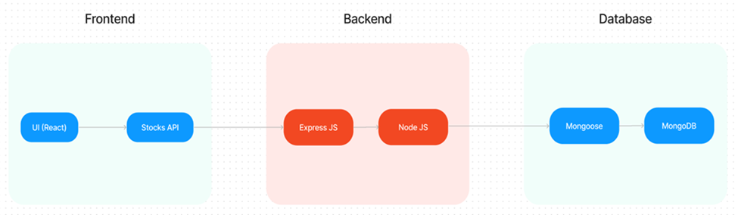

This high-level DFD visualizes the flow of data and control in the application from both user and admin perspectives.

**3.4 Technology Stack**

|  |  |
| --- | --- |
| Component | Technology |
| Frontend | React.js, Bootstrap |
| Backend | Node.js, Express.js |
| Database | MongoDB Atlas |
| Auth/Security | JWT, Bcrypt.js |
| Styling | CSS, Styled-components |
| Hosting | Localhost or Vercel |

This technology stack ensures scalability, speed, and ease of integration across all parts of the application lifecycle.

**4. PROJECT DESIGN**

**4.1 Problem-Solution Fit**

**Problem:** Many consumers face challenges in grocery shopping due to time constraints, traffic, and product availability. Simultaneously, grocery store admins struggle with order tracking, inventory updates, and customer management using traditional methods.

**Solution:** The Online Grocery Store application offers a unified digital solution that benefits both parties. Customers get the ability to shop anytime, view products with real-time stock availability, and place orders without visiting stores. Admins get an intuitive backend panel that allows them to monitor stock, process orders, and manage users efficiently.

**4.2 Proposed Solution**

The following core components make up the proposed technical and functional solution:

* **Role-Based Login:** Separate login mechanisms for users and administrators. Admin routes and components are protected and accessible only by verified admin tokens.
* **Cart and Checkout System:** Products can be added to a virtual cart. On checkout, users fill out a form that includes quantity, payment method, and address. The order is then created and saved to the database.
* **MongoDB Schemas:** Four main schemas—Users, Products, Categories, and Orders—are designed to handle data structure and validation. These schemas ensure consistent data flow and provide API integration ease.
* **Admin Dashboard:** After login, admins see statistics, manage product lists, add categories, and change order statuses (Pending, Shipped, Delivered). The dashboard is a protected route with privileged access.

**4.3 Solution Architecture**

Frontend (React.js)

↓

API Server (Express.js + Node.js)

↓

Database (MongoDB Atlas)

* **Communication:** React frontend communicates with backend via RESTful APIs.
* **Authentication:** JWT tokens stored in browser cookies or local storage.
* **Data Transmission:** Axios/fetch is used for sending/receiving JSON data.
* **Security:** Middleware checks for JWT validity before accessing sensitive routes.
* **Routing:** React Router for client-side routing; Express Router for backend API endpoints.

This architecture ensures clear separation of concerns, scalable deployment, and secure access control.

**5. PROJECT PLANNING & SCHEDULING**

**5.1 Project Planning**

The following timeline was used to plan and execute the development process over a period of 6 weeks:

|  |  |
| --- | --- |
| Week | Task Description |
| 1 | Environment setup, initializing Node.js backend, database configuration with MongoDB Atlas |
| 2 | Designing and implementing user registration and login with JWT and bcrypt |
| 3 | Developing product listing and category filtering functionalities |
| 4 | Implementing cart logic and complete order placement flow |
| 5 | Setting up the admin dashboard and integrating order/product/user management features |
| 6 | Final testing, debugging, UI refinements, and report/documentation preparation |

This structured timeline ensured timely completion of project modules and effective coordination between frontend and backend components.

**6. FUNCTIONAL AND PERFORMANCE TESTING**

**6.1 Functional Testing**

Functional testing was carried out to ensure that each individual feature of the Online Grocery Store application works as intended. This included testing user-facing functionalities as well as administrative tools. Below is a summary of the key functional modules and how they were verified:

**User Side**

* **User Registration & Login:**
  + Verified that users could register with valid inputs.
  + Tested login with valid and invalid credentials.
  + Ensured JWT tokens are created and stored after login.
* **Product Listing & Filtering:**
  + Confirmed product list loads from backend.
  + Validated search functionality returns correct results.
  + Tested category filters by applying different categories.
* **Cart Functionality:**
  + Added and removed products from cart.
  + Verified that cart persisted items until cleared or purchased.
* **Order Placement:**
  + Submitted order forms with valid/invalid data.
  + Checked that all order data is saved in MongoDB.
* **Order History Tracking:**
  + Confirmed users can see past orders and current order status.

**Admin Side**

* **Admin Login:**
  + Validated login and role-based dashboard access.
* **Product Management:**
  + Tested adding, editing, deleting products from admin panel.
* **User Management:**
  + Confirmed that admins can view and remove users.
* **Order Management:**
  + Verified order list rendering.
  + Ensured status update flows (Pending → Shipped → Delivered).

**6.2 Performance Testing**

Performance testing was conducted to measure how the application behaves under load and how responsive the APIs are during high usage.

**API Response Time (Tested with Postman)**

* Tested multiple endpoints (login, register, product list, cart, orders).
* Average response time observed: **< 250ms** under normal load.
* API failed gracefully with appropriate status codes when errors occurred.

**Load Testing**

* Simulated multiple concurrent users using browser sessions and Postman runner.
* Tested 10+ simultaneous user sessions logging in and placing orders.
* System maintained performance and consistency without database crashes.

**Stress & Edge Case Testing**

* Tried invalid email formats, missing fields during registration.
* Simulated adding 100+ items to cart to test data handling.
* Tested empty product/category cases to ensure UI gracefully degrades.

**Tools Used**

| **Tool** | **Purpose** |
| --- | --- |
| **Postman** | API testing and automation |
| **Browser DevTools** | Real-time network monitoring & error debugging |
| **Console Logs** | Backend API tracing and validation |
| **MongoDB Atlas Monitoring** | Monitored database performance & query logs |

**6.3 Observations & Improvements**

* The app remains highly responsive for typical usage loads (5–20 concurrent users).
* Form validation helped catch errors early at client-side.
* Security middleware (JWT, role-checking) ensured only proper users accessed protected routes.

## 7. RESULTS

### 7.1 Output Screenshots

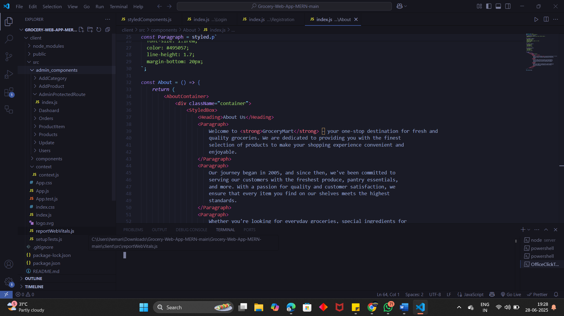 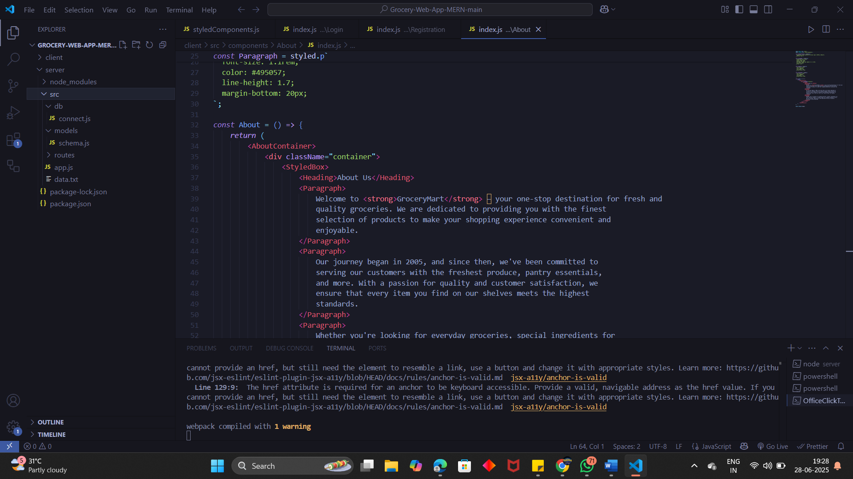

Frontend Backend

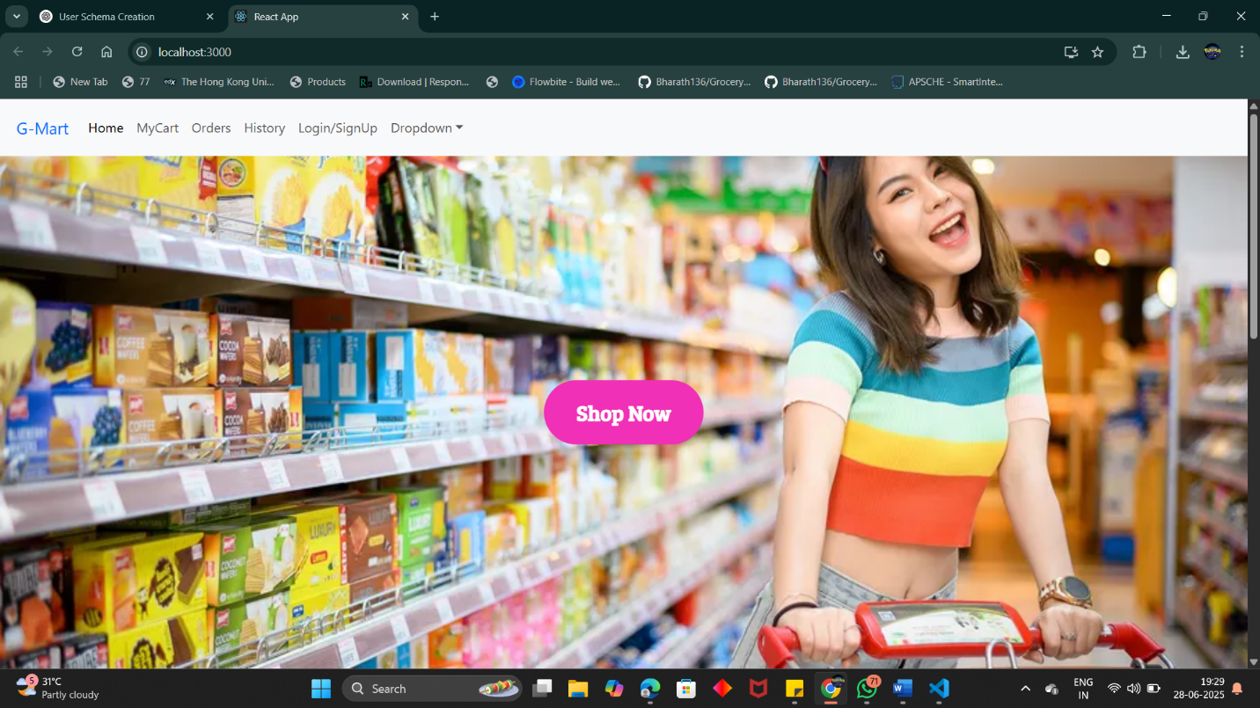

App Home Page

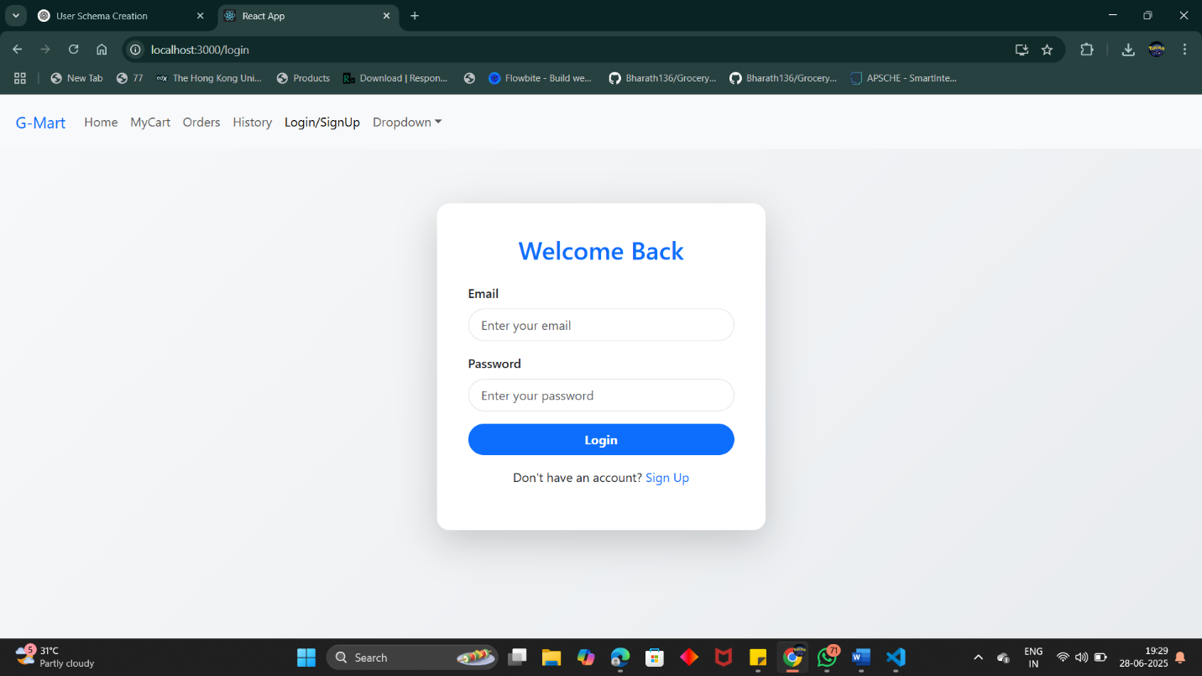

Login Page

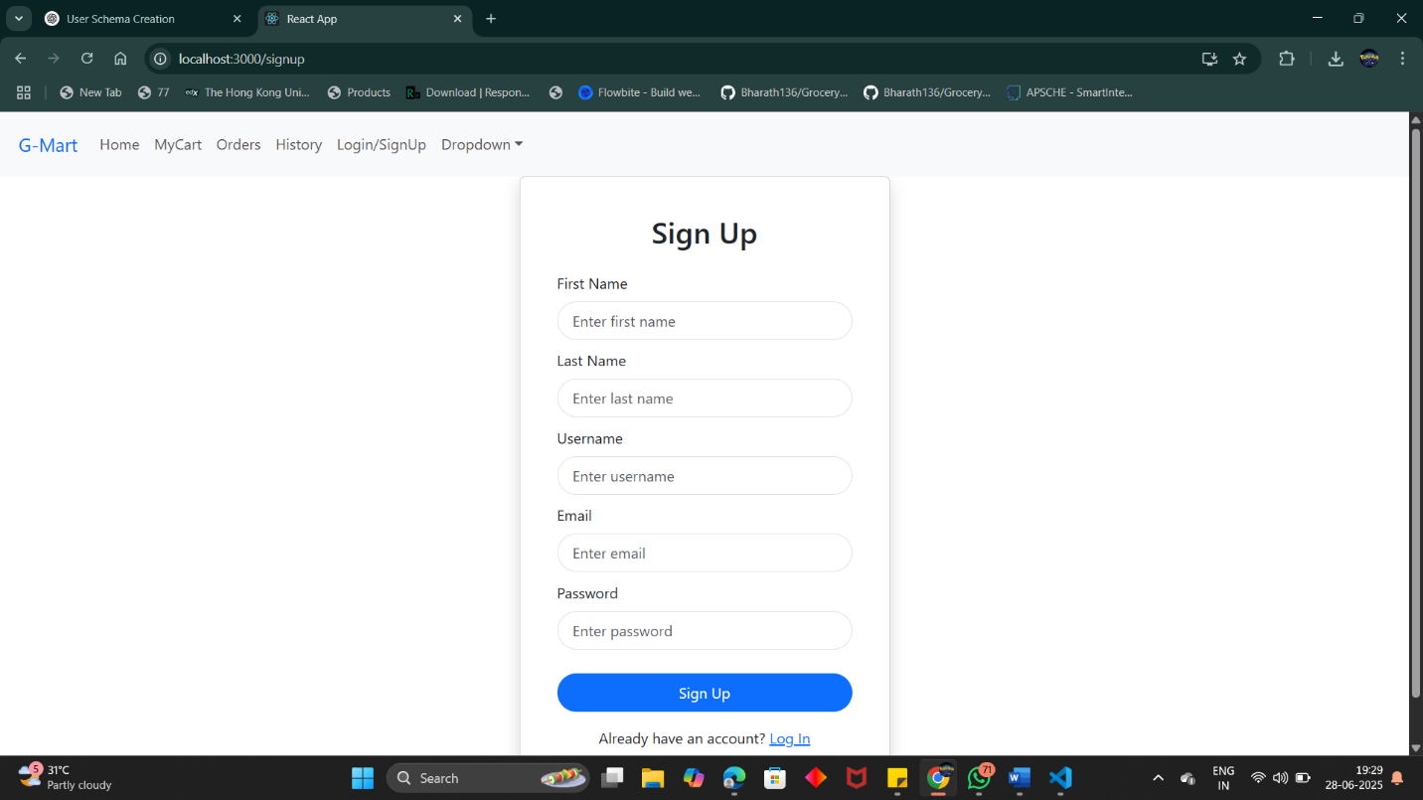

Register Page

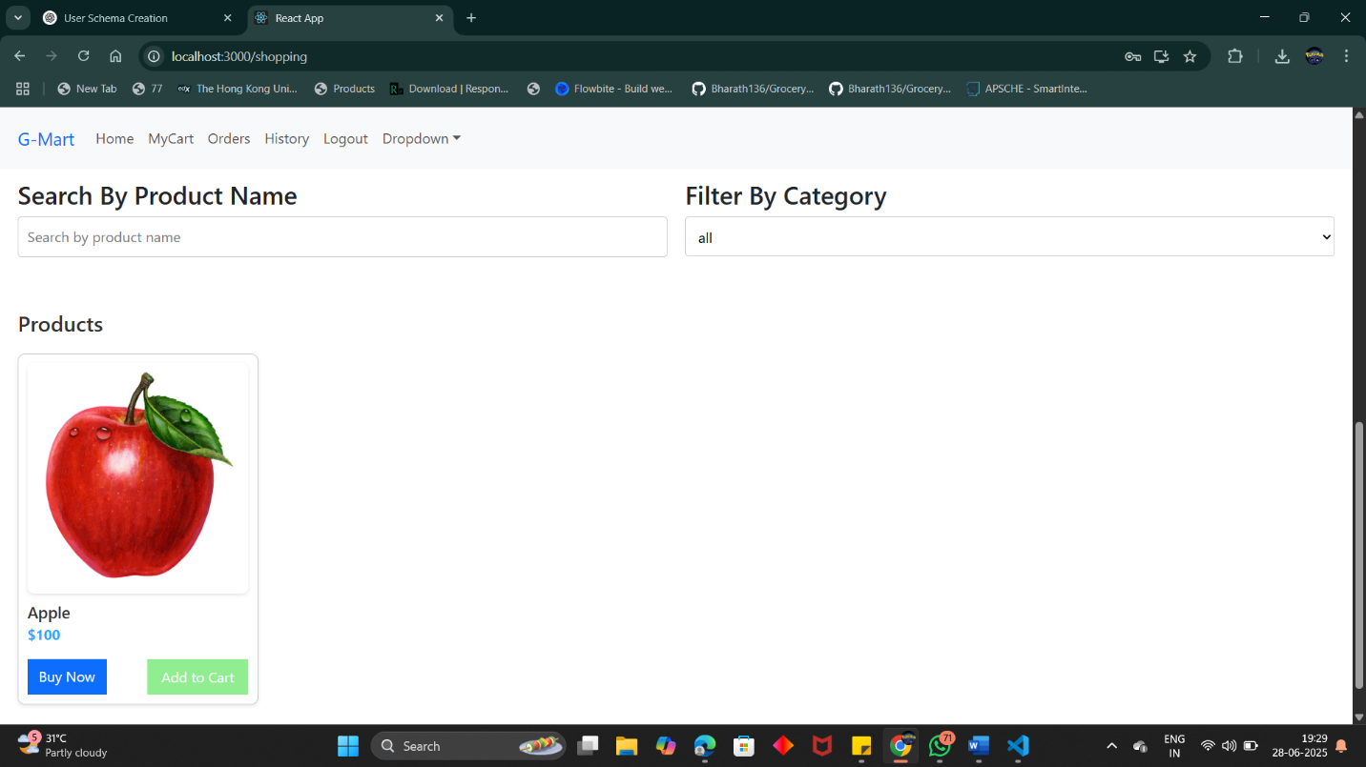

Products Page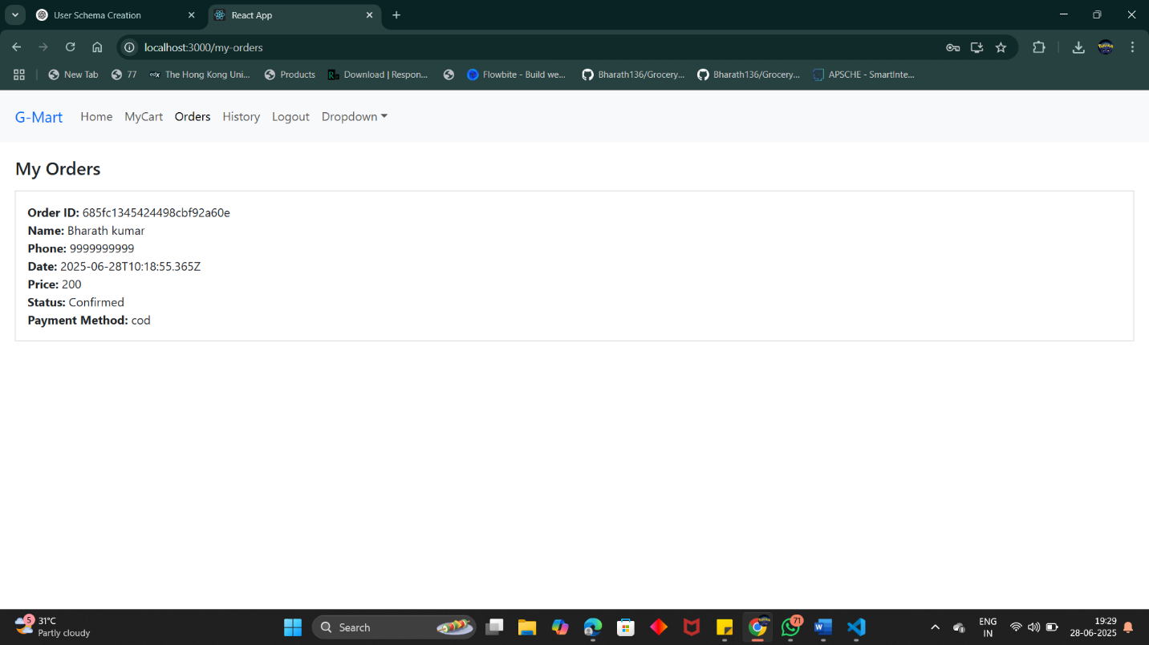

User Order Page

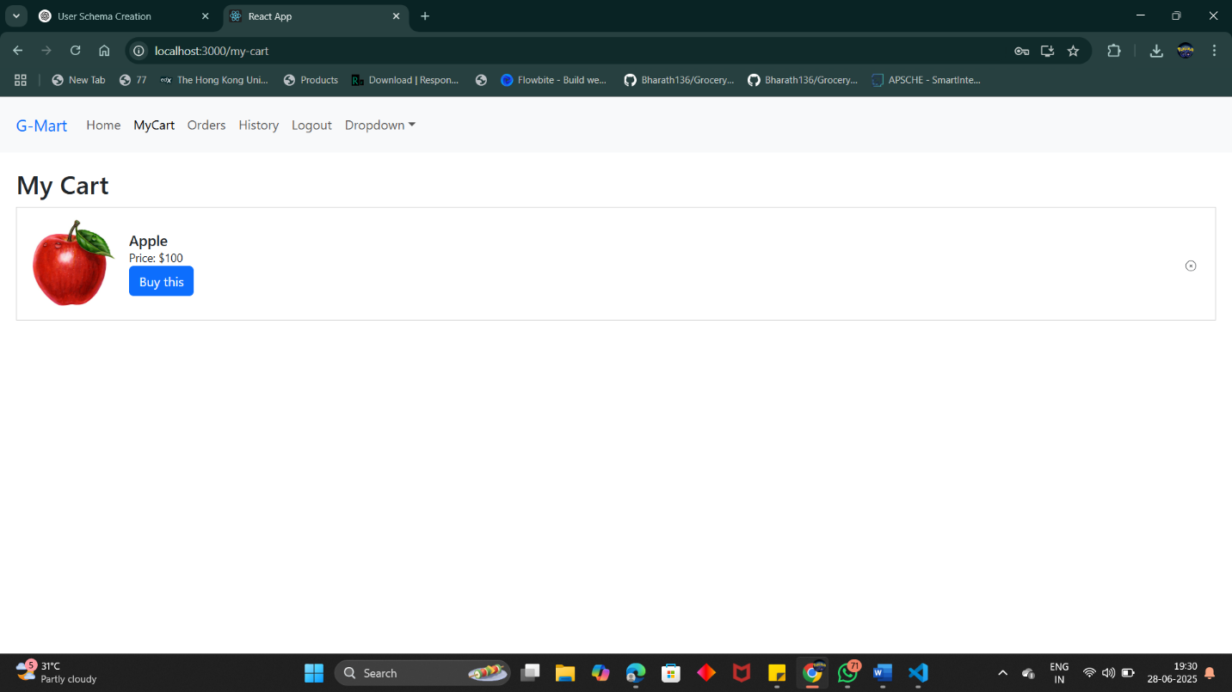

User Cart Page

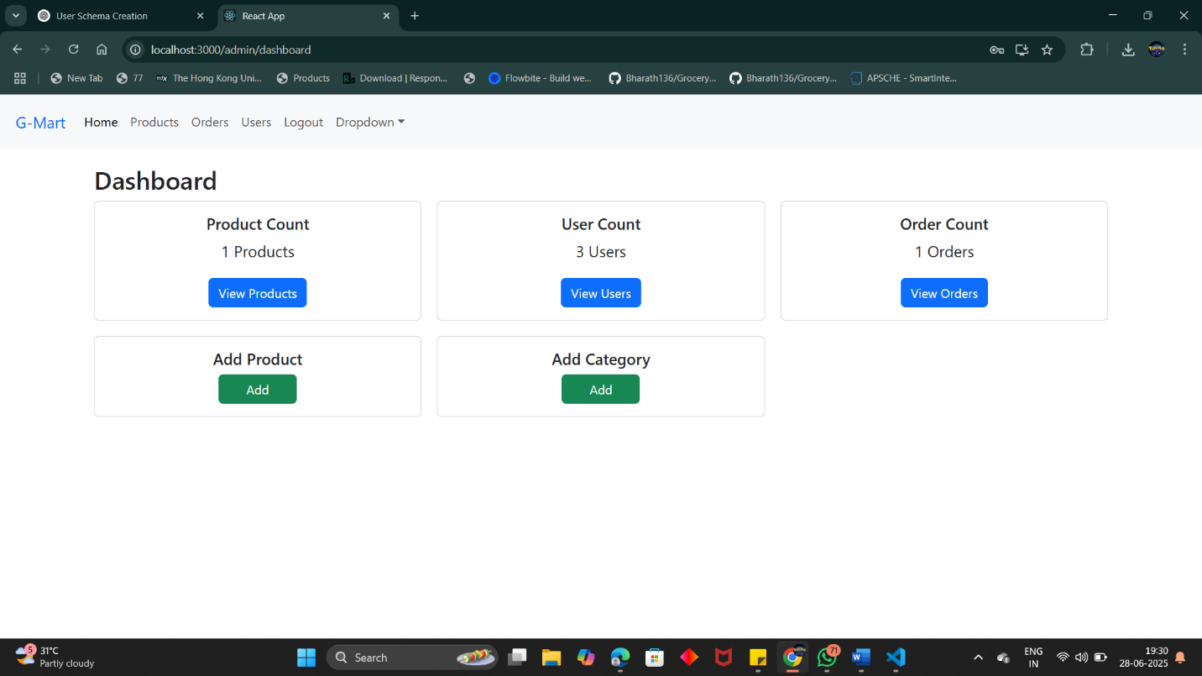

Admin DashBoard

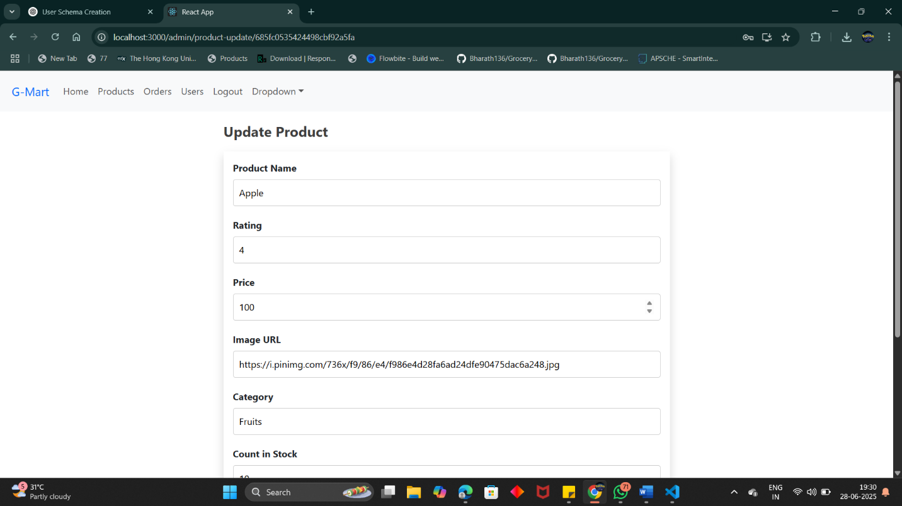

Update Product

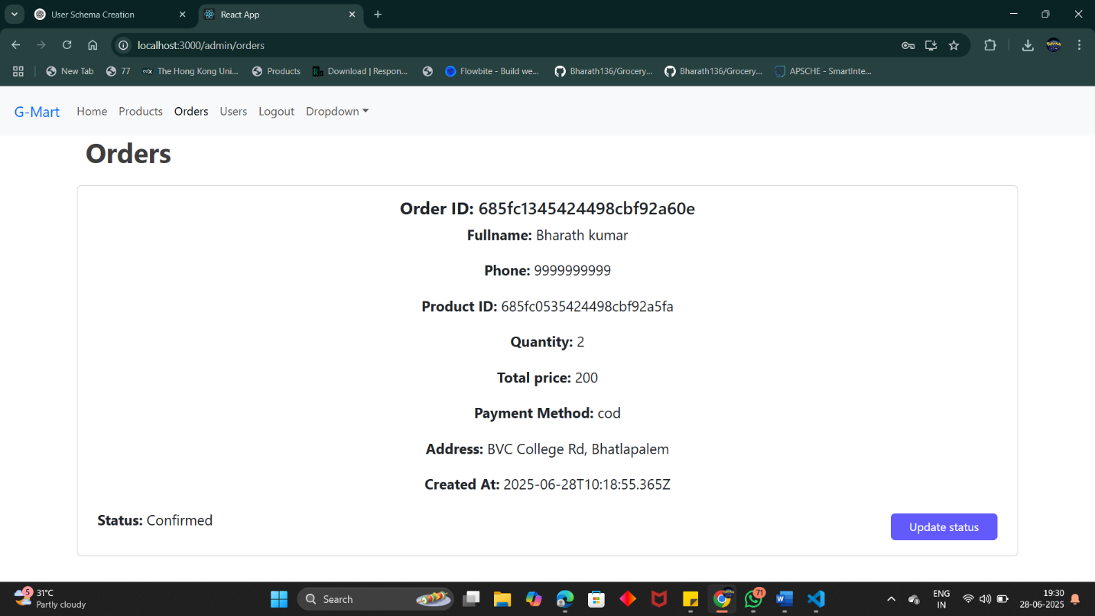

Admin Orders Page

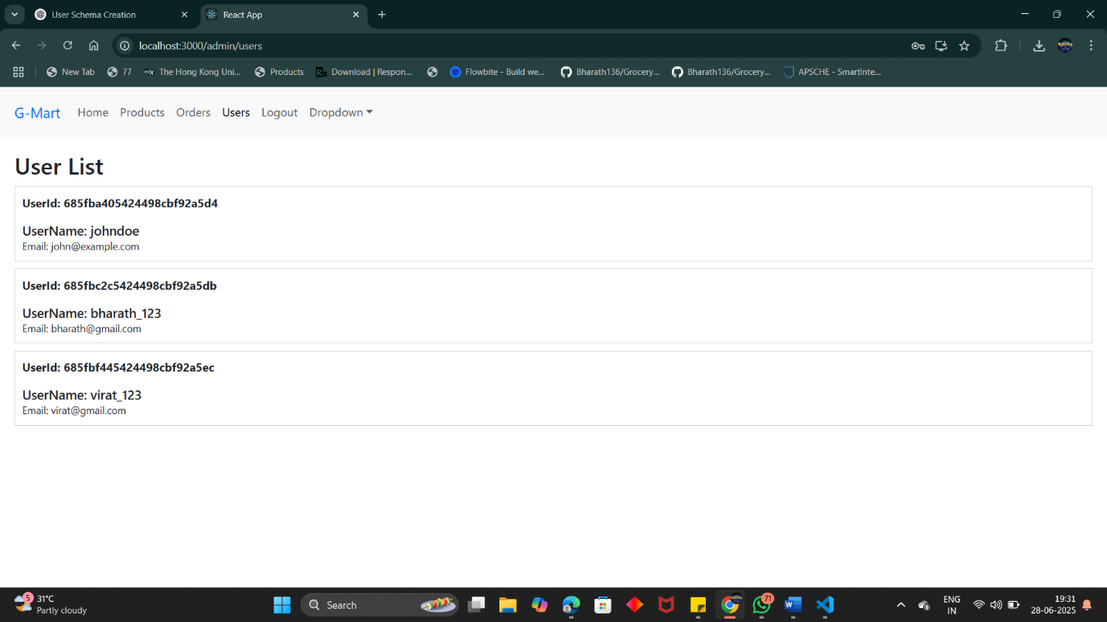

Admin Users Page

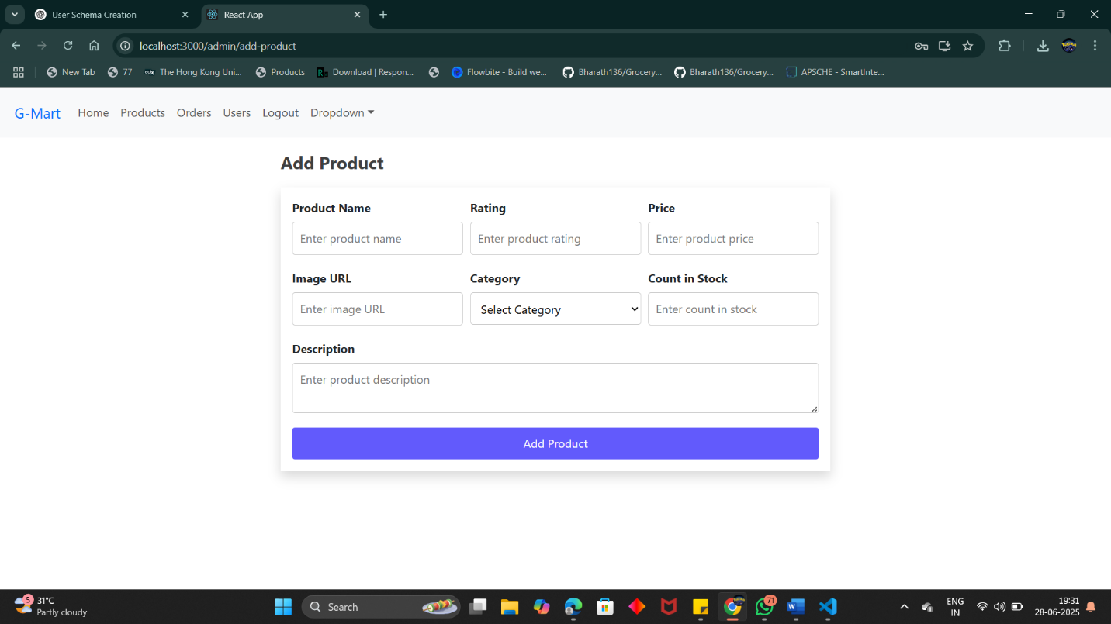

Add Product

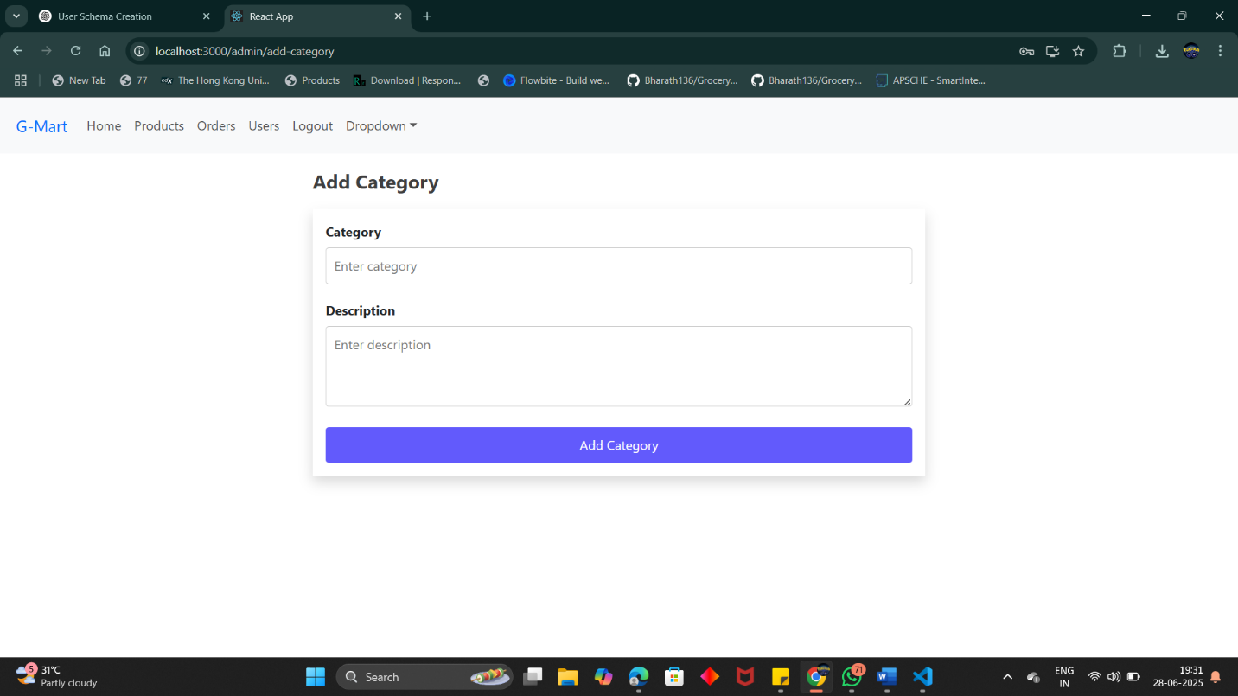

Add Category

## **8. ADVANTAGES & DISADVANTAGES**

**8.1 Advantages**

1. **User Convenience**  
   The system enables users to shop for groceries from anywhere at any time, removing the need for physical store visits.
2. **Real-Time Product Management**  
   Admins can add, update, and delete products instantly. Changes reflect immediately on the frontend.
3. **Scalable Architecture**  
   Using MongoDB Atlas, the system can scale vertically and horizontally, supporting future traffic and data growth.
4. **Secure Access Control**  
   Role-based login with JWT ensures that only authorized users and admins can access sensitive operations.
5. **Responsive UI**  
   Built with React and Bootstrap, the interface works well across all modern devices and screen sizes.
6. **Cloud Integration**  
   Cloud database hosting enables reliability, faster access, and remote development without the need for local DB servers.
7. **Component Reusability**  
   React components are modular and reusable, ensuring faster feature development and easy code maintenance.

**8.2 Disadvantages**

1. **No Payment Gateway**  
   The current system uses a mock payment flow. There is no integration with real gateways like Stripe or Razorpay.
2. **Lack of Real-Time Order Tracking**  
   Although the system updates order status, it does not have live tracking or notifications yet.
3. **Limited Analytics**  
   Admins don’t currently have graphical reports or insights on best-selling products or order trends.
4. **No Inventory Alerts**  
   The system doesn’t alert admins for low-stock or out-of-stock items.

## **9. CONCLUSION**

The Online Grocery Store project fulfills its goal of offering a robust, full-stack platform for digital grocery shopping. It bridges the gap between consumers and grocery providers by creating a user-friendly interface for customers and a feature-rich admin panel for business operations.

From user registration and secure authentication to real-time product browsing and order management, the system offers an end-to-end solution for a grocery e-commerce business. The MERN stack was chosen for its efficiency, performance, and popularity in full-stack web development.

The use of MongoDB Atlas as a cloud-based solution ensures that the application remains scalable and reliable. By adhering to modern design practices and secure authentication techniques, the project is both practical and production-ready.

This project has successfully demonstrated the application of theoretical knowledge into a practical, real-world software product.

**10. FUTURE SCOPE**

The application is designed with scalability in mind. The following enhancements are proposed for future iterations:

1. **Payment Gateway Integration**  
   Add Stripe, Razorpay, or PayPal for secure online transactions.
2. **Progressive Web App (PWA)**  
   Convert the React app into a PWA to allow users to install it on mobile and access offline features.
3. **Push Notifications**  
   Integrate Firebase Cloud Messaging (FCM) for sending order updates and promotional alerts.
4. **Inventory Management Module**  
   Provide detailed inventory tracking and restocking alerts for admins.
5. **Order Invoice Generation**  
   Generate downloadable PDF receipts upon order confirmation.
6. **AI-Based Product Recommendations**  
   Analyze user behavior and suggest relevant items to increase engagement and sales.
7. **Multi-Admin Roles**  
   Add role segmentation within the admin dashboard (e.g., Order Manager, Product Manager).
8. **Customer Review System**  
   Allow users to rate and review products to improve trust and transparency.

## **11. APPENDIX**

**GitHub :** <https://github.com/Hemanth1551/smartbridgeproject>

**Dataset Used :** Product and category data (custom created)

**Project Demo :** <https://github.com/Hemanth1551/smartbridgeproject/blob/main/Video%20Demo/Untitled%20design.mp4>